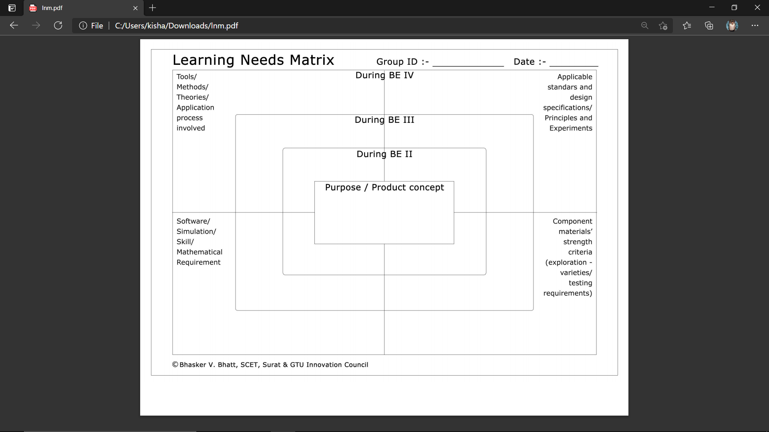

DOMAINAL AREA

OOP CONCEPT/ AUTHENTICTION

ACTIVE WEB TECH.

DATABASE CONCEPT

PROTOCOL LAYERS

SOFTWARE ENGG. IT ENGG.

WIRELESS COMM.

UX / UI IMPLEMENTS

TELESIGN SMS API

DATA SECURITY

HIGH END PC

NUM & STAT. METHOD

WEB APP FOR STUDENT PROGRESS REPORT & ANALYSIS

2 8 5 0 7 4